
National College of Computer Studies
(NCCS-College of IT & Management)
Final Examination (2020)
BCA/First Semester/ CAMT104: Mathematics ICandidates are required to answer the questions in their own words as far as practicable.

Full Marks: 10
Time: 20 minutes
Set A

Name:………………………………………………………………………….

NCCS Reg no :………………………………..
Attempt all the questions
- Circle ( ) the correct answer. [10× 1=10]
- If 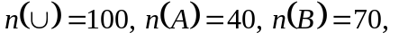What is the minimum value of 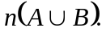
a) 60 b) 100 c) 70 d)
- The solution set of 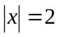is.
a) 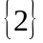 b) 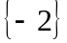 c) d) 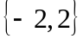
- The domain of 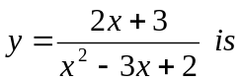
a) R-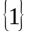 b) R-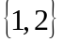 c) R d) R-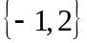
- The relation ‘is less than’ in the set of Natural numbers is
a)Symmetric b) Transitive c) Reflexive d)Equivalence Relation
- Let a, b, c, d ……………. be an A.P and K be any constant number not equal to zero then 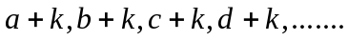are in
a) H.P. b) A.P. c) G.P. d) All of above
- If A is the square matrix then 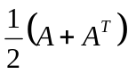is a
a) Square Matrix b) Scalar Matrix
c) Symmetric Matrix d) Skew-Symmetric Matrix
- If a is a square matrix then which of the following is always true?
a) 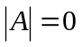 b) 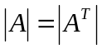 c) 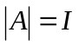 d) 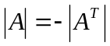
- The foci of the hyperbola 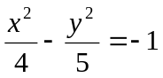 are
a) 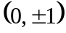 b) 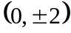 c) 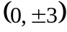 d) 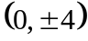
- Vector projection of 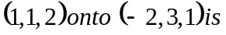
a) 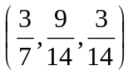 b) 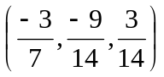
c) 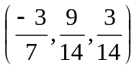 d) 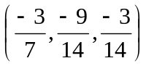
- In how many ways can 10 different beads from a bracelet?
a)181440 b) 811044 c) 441180 d) 414018

National College of Computer Studies
(NCCS-College of IT & Management)
Final Examination (2020)
BCA/First Semester/ CAMT104: Mathematics ICandidates are required to answer the questions in their own words as far as practicable.

Full Marks: 10
Time:20 minutes
Set B

Name:………………………………………………………………………….

NCCS Reg no :………………………………..

Attempt all the questions
- Circle ( ) the correct answer. [10× 1=10]

- If 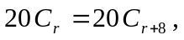What is the value of r?
a) 7 b) 6 c) 12 d) 10

- The vector triple product 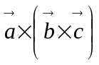 is given by
a) 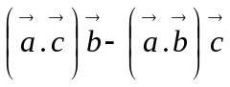 b) 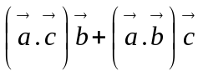
c) 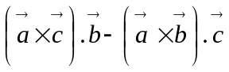 d) 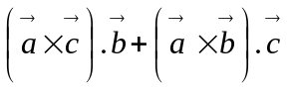
- The radius of the circle 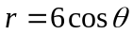is
a) 1 b) 2 c) 3 d) 4
- A square matrix A is said to be orthogonal if
a) 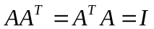 b) 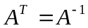 c) 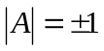 d) All of above
- If A is a square matrix then 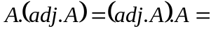
a) 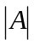 b) 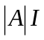. c) 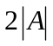. d) 4A
- If 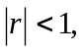then the geometric series 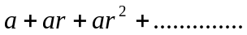 converges to
a) 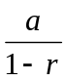 b) a c) 1 d) 0

- If 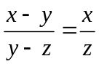then x, y, z are in
a) A.P b) G.P c) H.P d) A.G.P

- A function 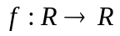defined by 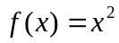is
a) One to one b) Onto c) Bijective d) None of these
- The value of 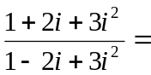

a) -1 b) 1 c) – i d) i
- If 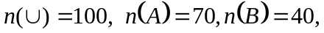what is the maximum value of 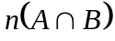

a) 40 b) 70 c) 45 d) 0

